CSE211 Web Programming, Fall Semester 24/25 Assignment 1 Websites conceptual Design and mock-up Oday ashraf elsayed ali 221101245

## Part 1 ( resarch )

1. **Characteristics of Web 2.0 through Web 4.0**
   * **Web 2.0** - *The "Social Web"*:
     + Emphasizes user-generated content, interactivity, and social networking.
     + Central features include blogs, social media platforms, and content-sharing tools.
     + This phase empowered users to participate actively, reshaping the internet into a two-way interactive space.
   * **Web 3.0** - *The "Semantic Web"*:
     + Focuses on creating a more customized browsing experience with AI and machine learning, allowing the web to interpret data with contextual meaning.
     + Features include semantic search, personalized content, and AI-driven insights.
     + This phase connects data and knowledge more meaningfully by delivering relevant results and suggestions to users.
   * **Web 4.0** - *The "Intelligent Web"*:
     + Known for its advanced integration of humans and machines, emphasizing the Internet of Things (IoT), automation, and enhanced AI capabilities.
     + Key features are real-time communication, IoT connectivity, and virtual assistants.
     + This stage supports "intelligent connections," making interactions more fluid, intuitive, and tailored to the individual.

## Key Features of Web 2.0 and Their Impact on Networks

* + **Features**: User-driven content, social networking, tagging, and collaborative communities.
  + **Impact**: Web 2.0 shifted the internet from a static information source to a vibrant, interactive platform, where users and businesses could create connections and communities around shared interests.

## Key Features of Web 3.0 and How They Enhance Data and Knowledge Connections

* + **Features**: Semantic searches, personalization, machine learning, and insights powered by data.
  + **Impact**: Web 3.0 allows the web to interpret user data, producing highly relevant results and personalized experiences, thereby fostering a more meaningful and insightful relationship between users and content.

## Key Features of Web 4.0 and How They Foster Intelligent Connections

* + **Features**: AI integration, IoT, automation, real-time communication, and virtual assistants.
  + **Impact**: Web 4.0 enables an interconnected ecosystem where devices and systems work together seamlessly, providing real-time responses and actions. This creates "intelligent connections," making online interactions more adaptive and responsive to individual needs.

## The Role of Collective Intelligence, Social Networking, Social Media, and Social Bookmarking

* + **Collective Intelligence**: Aggregates knowledge from large groups of users, promoting accurate information and inspiring innovation.
  + **Social Networking**: Fosters connections, collaboration, and communities, both socially and professionally.
  + **Social Media**: Provides a platform for sharing content and ideas, contributing to diverse and global discussions.
  + **Social Bookmarking**: Enables users to save and organize information, making valuable resources more accessible and shareable.

Together, these elements help create a more connected and information-rich web environment.

## Impact of These Technologies on Current and Future Business Strategies

* + **Current Impact**: Web technologies from Web 2.0 to Web 4.0 empower businesses to communicate effectively with customers, tailor user experiences, and leverage data insights for better decision-making.
  + **Future Impact**: Emerging advancements, especially in Web 4.0, will drive greater automation, intelligent processes, and insights into customer behaviors, paving the way for innovative business models and improved efficiency.

## Potential Applications of Advanced Technologies in Your Profession

Consider how developments in AI, IoT, and big data could benefit your field:

* + **Marketing**: Web 3.0 and 4.0 technologies could enable highly personalized marketing campaigns and real-time engagement with customers.
  + **Healthcare**: AI and IoT could revolutionize patient care, streamline health data management, and enable remote monitoring.

**Part 2 ( website planning )**

# Define Your Goals and Target Audience

* + **Identify Business Goals**: Clarify your business objectives, whether it's sales growth, brand awareness, or customer engagement.
  + **Target Audience**: Define who your primary customers are. Research their demographics, shopping preferences, and online behaviors to create an experience that meets their needs.

# Choose Your Business Model

* + **B2C (Business-to-Consumer)**: Directly selling products to end customers.
  + **B2B (Business-to-Business)**: Selling products to other businesses.
  + **C2C (Consumer-to-Consumer)**: Facilitating transactions between consumers (like marketplaces).
  + **Subscription-Based**: Customers subscribe to receive products periodically.

# Select Your Product Niche and Inventory Strategy

* + **Product Selection**: Decide what products you’ll offer. Aim to select a mix of popular and unique items that differentiate your brand.
  + **Inventory Management**: Decide between managing your own inventory, dropshipping, or a hybrid approach.

# Plan the Website Structure

* + **Homepage**: Capture attention with your brand’s unique selling points (USPs), popular products, and easy navigation.
  + **Category Pages**: Organize products by categories to help users find what they need easily.
  + **Product Pages**: Include high-quality images, descriptions, pricing, reviews, and an "Add to Cart" button.
  + **Cart and Checkout**: Design a simplified, secure, and user-friendly checkout process.
  + **Other Pages**: About Us, Contact, FAQs, Shipping, and Return Policies.

# Select a Platform and Tech Stack

* + **E-commerce Platforms**: Consider Shopify, WooCommerce, Magento, BigCommerce, or custom development.
  + **Content Management System (CMS)**: Choose a CMS that integrates with your e- commerce platform if you’ll publish content.
  + **Plugins and Integrations**: Look for tools to manage inventory, marketing, analytics, and payment gateways.

# Design for User Experience (UX)

* + **Responsive Design**: Ensure the site is optimized for mobile, tablet, and desktop users.
  + **Navigation**: Keep navigation intuitive with search bars, category filters, and breadcrumb trails.
  + **Visual Appeal**: Use high-quality images, a consistent color scheme, and a clear font style.
  + **Loading Speed**: Optimize site performance to prevent customer drop-off due to slow load times.

# Optimize Product Pages

* + **High-Quality Images**: Use multiple images per product, showing different angles and close-ups.
  + **Detailed Descriptions**: Include essential details, materials, size, care instructions, etc.
  + **Customer Reviews**: Allow reviews to build trust and showcase social proof.
  + **Related Products**: Suggest complementary items to increase the chances of upselling.

# Set Up Payment and Shipping Options

* + **Payment Gateways**: Choose trusted options like PayPal, Stripe, and direct bank transfers.
  + **Shipping Options**: Offer various shipping methods and display estimated delivery times and costs.
  + **Security Measures**: Use SSL encryption and comply with PCI-DSS standards for secure transactions.

# Focus on SEO and Content Marketing

* + **Keyword Optimization**: Research keywords relevant to your products and industry.
  + **Content Creation**: Start a blog, product guides, or tutorials to drive organic traffic.
  + **On-Page SEO**: Optimize title tags, meta descriptions, headers, and image alt texts.

# Implement Marketing Strategies

* + **Email Marketing**: Send personalized emails to engage with customers, offer discounts, and announce new products.
  + **Social Media**: Utilize platforms like Instagram, Facebook, and Pinterest to reach your audience and drive traffic.
  + **PPC Advertising**: Use Google Ads or social media ads to target customers based on demographics and interests.
  + **Affiliate Marketing**: Partner with influencers and affiliates to promote your products.

# Set Up Analytics and Tracking

* + **Google Analytics**: Track user behavior, conversions, and traffic sources.
  + **Heatmaps**: Use tools like Hotjar to visualize how users interact with your site.
  + **Conversion Tracking**: Measure the performance of campaigns, page performance, and areas of improvement.

# Testing and Launch

* + **User Testing**: Conduct tests to identify and fix usability issues.
  + **A/B Testing**: Test different elements like call-to-action buttons, layouts, and images to find what converts best.
  + **Soft Launch**: Launch in stages or to a select audience to resolve any issues before a full launch.

# Plan for Post-Launch and Continuous Improvement

* + **Customer Support**: Provide multiple channels for support, such as live chat, email, and phone.
  + **Continuous Optimization**: Regularly update product pages, add new content, and optimize based on user feedback.
  + **Monitor Competitors**: Stay aware of industry trends and competitor strategies to remain competitive.

**HTML5 Page Structure for Every Page**

**<!DOCTYPE html>**

**<html lang="en">**

**<head>**

**<meta charset="UTF-8">**

**<meta name="viewport" content="width=device-width, initial-scale=1.0">**

**<title>Page Title - Your E-commerce Site</title>**

**<link rel="stylesheet" href="styles.css"> <!-- Link to your CSS file -->**

**</head>**

**<body>**

**<!-- Header Section -->**

**<header>**

**<!-- Logo and Site Branding -->**

**<div class="logo">**

**<a href="index.html"><img src="logo.png" alt="Website Logo"></a>**

**</div>**

**<!-- Main Navigation -->**

**<nav>**

**<ul>**

**<li><a href="index.html">Home</a></li>**

**<li><a href="categories.html">Categories</a></li>**

**<li><a href="about.html">About Us</a></li>**

**<li><a href="contact.html">Contact</a></li>**

**</ul>**

**</nav>**

**<!-- Search Bar and Cart Icon -->**

**<div class="header-right">**

**<form action="search.html" method="get">**

**<input type="text" name="query" placeholder="Search...">**

**<button type="submit">Search</button>**

**</form>**

**<a href="cart.html" class="cart-icon">Cart</a>**

**</div>**

**</header>**

**<!-- Main Content Section -->**

**<main>**

**<!-- Page-Specific Content Goes Here -->**

**<section class="banner">**

**<!-- For Homepage Only: Promotional Banners or Featured Content -->**

**</section>**

**<section class="products">**

**<!-- For Category Pages and Homepage: Grid of Products -->**

**</section>**

**<section class="product-details">**

**<!-- For Product Pages: Product Details, Images, Reviews -->**

**</section>**

**<section class="cart">**

**<!-- For Cart Page: List of Items, Checkout Button -->**

**</section>**

**<section class="checkout">**

**<!-- For Checkout Page: Shipping and Payment Information Form -->**

**</section>**

**</main>**

**<!-- Footer Section -->**

**<footer>**

**<!-- Footer Links -->**

**<nav>**

**<ul>**

**<li><a href="terms.html">Terms of Service</a></li>**

**<li><a href="privacy.html">Privacy Policy</a></li>**

**<li><a href="faq.html">FAQ</a></li>**

**</ul>**

**</nav>**

**<!-- Social Media Links -->**

**<div class="social-media">**

**<a href="#"><img src="facebook-icon.png" alt="Facebook"></a>**

**<a href="#"><img src="twitter-icon.png" alt="Twitter"></a>**

**<a href="#"><img src="instagram-icon.png" alt="Instagram"></a>**

**</div>**

**<!-- Copyright Info -->**

**<p>&copy; 2023 Your E-commerce Site. All rights reserved.</p>**

**</footer>**

**<!-- Optional: JavaScript File Link -->**

**<script src="script.js"></script>**

**</body>**

**</html>**

e. Flowchart (Storyboard/Website Organization )

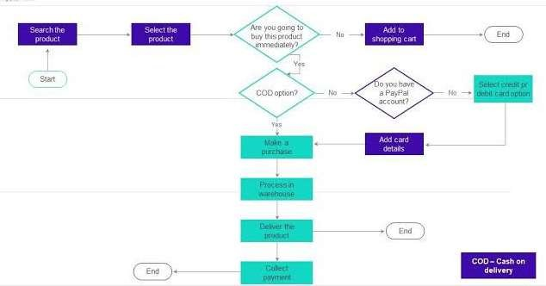

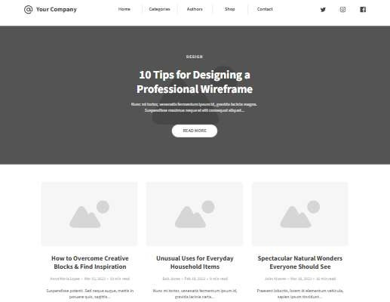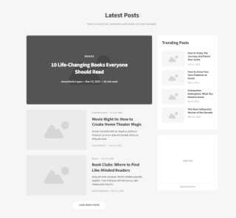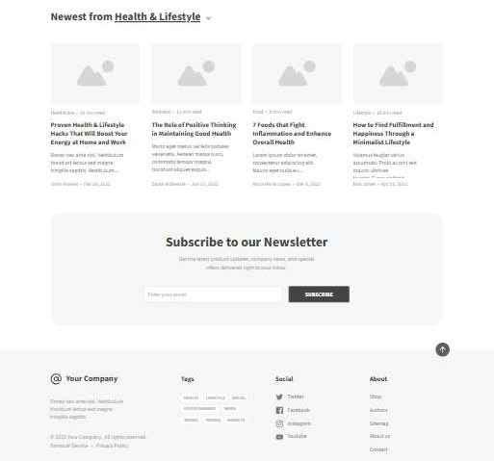**f. Create a wireframe for each page of your website using any computer tool. Make sure the logo, navigation, content, and footer regions are apparent. Save the produced wireframes as jpg or gif files.**